Cardiff anti-extremism program set for roll-out in Wales, Germany and Slovakia
Representatives from local authorities in Wales, Germany and Slovakia have visited Cardiff to discuss plans to roll out a project first piloted in the Welsh capital to tackle extremism and radicalization.
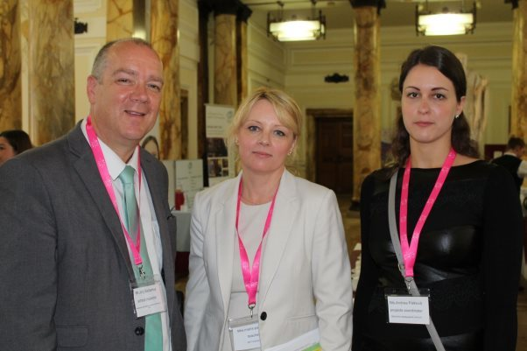
As a part of a three year European-funded project on using the primary school curriculum to challenge extremism, councils in Wales Germany and Slovakia are looking to adopt a similar approach to that used in Cardiff's Getting on Together (or also known as GOT project) first introduced in November 2016.
The GOT project was designed as a response to requests from teachers for guidance, resources and training to deliver learning experience for young learners which would challenge the misinformation that they might see online.
Developed with the help of Prevent and specialists in human rights, the project provides six lessons, covering a range of topics which include: stereotyping; extremism; propaganda; pupil voice; respecting other opinions; and what it means to be a good citizen.
This year's International Education Conference held at Cardiff City Hall, provided an opportunity for the Welsh, German and Slovakian counterparts to meet and discuss this approach being used in primary schools across all three countries.
Following consultations with parents it was piloted in areas of Wales, Germany and Slovakia between autumn 2017 and spring 2018. This is a small selection of references:
Ruth Jackson and Rachel Johns, Kitchener Primary School, Cardiff commented that “the teaching materials have been written by experienced teachers who are aware of the needs for practitioners to have age appropriate resources that support pupil discussion around extremism. The children’s responses have been very impressive; they have shown a highly reflective and mature approach”.
This is a quote from Paluck in Y6 at Severn Primary School, Cardiff:
“I really enjoyed the 'Challenging Extremism' lessons, I feel they are vital because it is necessary for the next generation (children of my age) to be aware of the dangers of stereotypes & propaganda. In my opinion the best part of the lessons was having the freedom to be able to enquire, explore & express our feelings about what is going on in the world”.

“At Roath Park Primary School, the project has served to highlight the importance of offering pupils the opportunity to discuss ideas and events in a safe environment, with teachers who are trained to approach sensitive topics with respect and in an inclusive way.”

"The topic was interesting and made me think about things I've heard about on the news". Y6 pupil Hassan
"We were able to work together and communicate together because we had real things to discuss in groups. It made me enjoy talking about what we were learning". Y6 pupil Max
Jörg Baldamus, from Nürnberger council in Germany, one of the pilot areas, said: "The collaboration between Germany, Slovakia and Wales has enriched the project to provide a safe environment for young pupils aged between eight and 11 to discuss, debate and challenge sensitive issues around extremism in today's society.
"At a young age, children learn to resist negative influences through positive experiences, and this enhances respect and tolerance towards others."
Alan Evans, Independent Evaluator of the Cardiff project, reported:
“A particularly pertinent insight derived from the delivery of the lessons was that the pupils involved appeared to appreciate the opportunity they were given to discuss topics which they had previously been led to believe were too sensitive for discussion and which teachers, indeed, might have been reticent to raise with their pupils.”
Cardiff council Cabinet Member with responsivity for community cohesion, Cllr Lynda Thorne, said: "As set out in our Capital Ambition, I want us to help make Cardiff communities a safe place to live, working with our partners to promote inclusion across the city.
"Seeing local authorities from across Wales, and in Germany and Slovakia coming to Cardiff to look at how we are challenging extremism is a great endorsement of the work we are doing to tackle the issue.
"But more importantly, this is also a great opportunity for us to work with those local authorities, to develop and share best practice in order to effectively challenge extremism in all its forms."
Over 300 people attended Cardiff Council's third Internationalising Education Conference, attracting visitors from 12 countries, including USA and Mexico. 30 workshops, on issues that included challenging extremism, creative arts and digital competence, were delivered by education professionals from Wales and across Europe.

https://www.cardiffnewsroom.co.uk/releases/c/19183.html

